Project Report

Our developer team for the Learning Management System consists of 4 members

1. Alan Saavedra
2. Edgar Santana
3. Mahendra Basyal
4. Sergio Toledo

Amongst each other we decided to form a Democratic team since we all felt that we are all on the same level when it comes to coding and we consider each other as egoless programmers. Another reason for this decision was that we consider that faults or “bugs” must be considered a normal and accepted event. Also, with a democratic we saw the opportunity to be able to assign subsystems of the project aspects amongst each other. For example, Alan would be in charge of GUI (Graphical User Interface) subsystem of the project. While Edgar and Sergio would be in charge of the code and the database and lastly Mahendra would be in charge of the documentation aspect of the project. We all developed our diagram and artifacts for respective parts since we would have the most knowledge of our respective parts and the most qualified. However, we could help each other with our code or just something else regarding the project.

GUI Diagram :

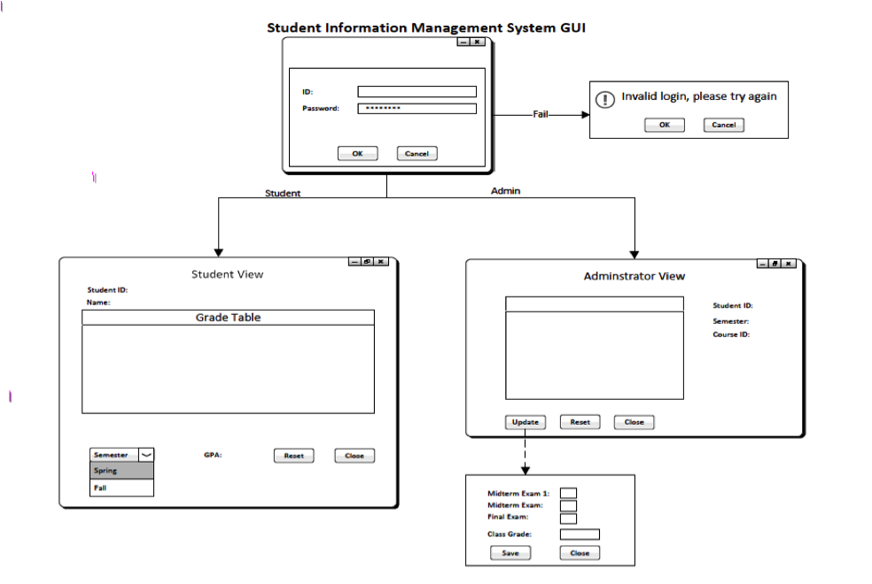

Data Flow Diagram:

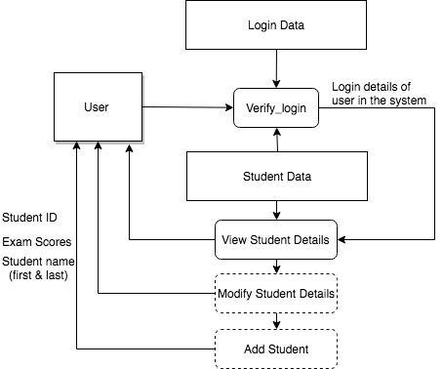

Use Cases: